

**School of Computing, Engineering and Physical Sciences**

**MSc Information Technology**

**COMP11113 Information Systems Analysis and Design**

**GROUP COURSEWORK 2 (60% of the marks)**

**Session 2024/2025 Term 1**

**Students**

1. Prajwalaradhya Shivakumaraswamy Kesaramadu (B01759301)
2. Aman Misra (B01746656)
3. Sreeraj Karuvanthodi Ramachandran (B01764963)
4. Muhammed Ali Panthalingal (B01755979)

Lecturer: Raja Ujjan, Ashraf Mahmud

Submission Date: 18-12-2024

**Declaration**

I have carefully read and fully understand Regulations 3.49–3.55 of Chapter 3 of the Regulatory Framework of the University of the West of Scotland, which outline the rules and policies regarding cheating and plagiarism.

I confirm that this assessment is the collective work of our group, consisting of five members, with each member contributing to the completion of this task. Where applicable, we have clearly referenced and acknowledged the contributions or ideas of others outside our group.

I also affirm that no part of this assessment has been written, in whole or in part, by anyone outside the group, except for explicitly referenced sources.

Furthermore, I confirm that this assessment has not been submitted previously, either partially or fully, for any other module or academic purpose, ensuring it does not fall under self-plagiarism.

This declaration is made with honesty and integrity in adherence to the University’s academic standards.

Table of Contents

Use Case Diagram for DVD Rental Store 4

1. Supplier and Inventory Management Use Case 4

2. Customer and Card Management Use Case 4

3. DVD Rental & Return Processing Use Case 5

Class Diagram for DVD Rental Store 6

# Use Case Diagram for DVD Rental Store

## Supplier and Inventory Management Use Case

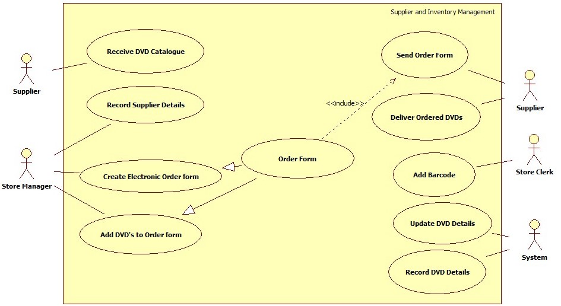

## Customer and Card Management Use Case

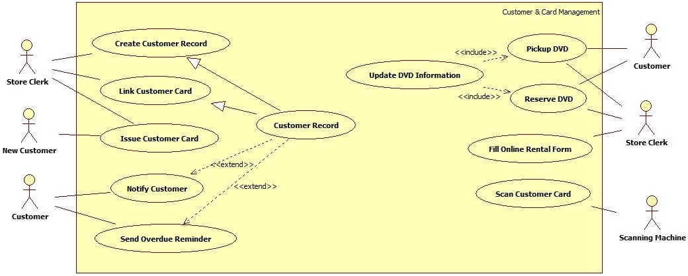

## DVD Rental & Return Processing Use Case

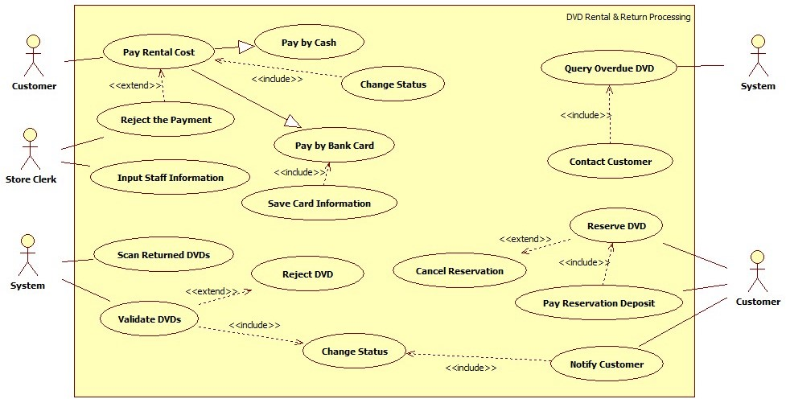

# Class Diagram for DVD Rental Store

